Québec, Février 2023

Chers amis sonneurs,

À l’occasion de la St-Valentin, la guilde des sonneurs de Québec vous envoie son plus tendre message d’amour et espère pouvoir vous le répéter de vive voix lors de son prochain May Weekend qui se tiendra du 26 au 29 mai 2023. D’ici là, sonnez dans la joie pendant que nous continuons à travailler fort pour améliorer nos sonneries.

Dear ringing friends

The Quebec City Bell Ringers send you our warmest Valentine’s Day wishes and look forward to seeing you in this romantic city during our May Weekend, which will be held from May 26 to 29, 2023. Don’t miss the weekend! It is the first time in three years that we’ve been able to host the event. We’d love to ring with you.

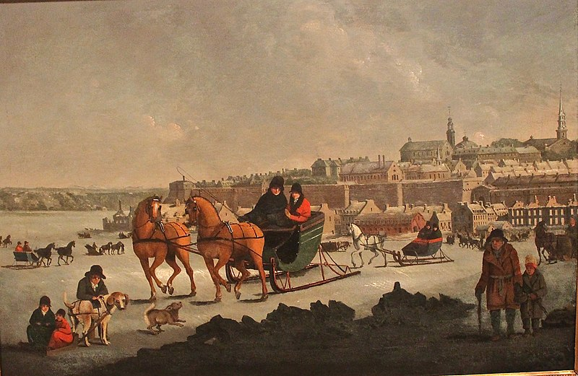

"The North west part of the city of Quebec" by George Heriot. The Cathedral of the Holy Trinity is the tower on the right, near the edge of the picture. This is the first time the Cathedral, built between 1800-1804 was painted. The image of ice sleighsnn on the frozen river dates from 1805. Nowadays this spot is a favourite ice fishing spot well into March, before spring break up.

