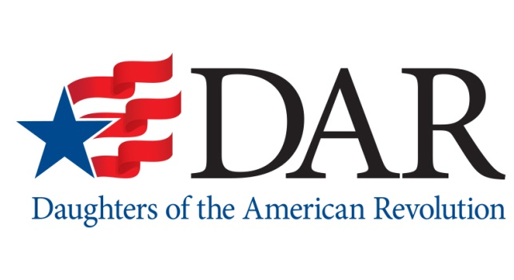
NEWS
DAR National Headquarters
1776 D Street NW
Washington, DC 20006
www.dar.org

Contact:

FOR IMMEDIATE RELEASE Dawn Sieber
September 1, 2021 612-986-5555
Anokasieber@msn.com

CELEBRATE THE FOUNDATION OF AMERICA
DAR Promotes Constitution Week: September 17-23

WASHINGTON, DC – The National Society Daughters of the American Revolution urges Americans to reflect on the United States Constitution during this month’s annual observance in honor this foundational document of national governance.

“There are two documents of paramount importance to American history: the Declaration of Independence, which forged our national identity, and the United States Constitution, which set forth the framework for the federal government that functions to this day,” said DAR President General Denise Doring VanBuren. “While Independence Day is a well-recognized and beloved national holiday, fewer people know about Constitution Week, an annual commemoration of the living document that upholds and protects the freedoms central to our American way of life.”

The DAR initiated the observance in 1955, when the service organization petitioned the U.S. Congress to dedicate September 17–23 of each year to the commemoration of Constitution Week. Congress adopted the resolution, and on August 2, 1956, President Dwight D. Eisenhower signed it into Public Law #915. The celebration’s goals are threefold: to encourage the study of the historical events that led to the framing of the Constitution in September 1787; to remind the public that the Constitution is the basis of America’s great heritage and the foundation for its way of life; and to emphasize U.S. citizens’ responsibility to protect, defend and preserve the U.S. Constitution.

DAR has been the foremost advocate for the awareness, promotion and celebration of Constitution Week. The annual observance provides innumerable opportunities for educational initiatives and community outreach, two mission areas of crucial importance to the National Society. By fostering knowledge of, and appreciation for, the Constitution and the inalienable rights it affords to all Americans, DAR helps to keep alive the memory of the men and women who secured our nation’s foundational liberties.

“In communities across America, Daughters will erect hundreds of community displays, sponsor municipal proclamations, ring bells and stage programs to raise awareness of the Constitution’s tenets and importance. We invite everyone to join us in celebrating this powerful document, which has enabled our democracy within a republic for more than two centuries. We hope that all Americans will learn more about the Constitution and its immense impact on our nation,” VanBuren said.

One of the largest patriotic women’s organizations in the world, DAR has more than 190,000 members in approximately 3,000 chapters across the country and several foreign countries. DAR members promote historic preservation, education and patriotism via commemorative events, scholarships and educational initiatives, citizenship programs, service to veterans, meaningful community service and more. For additional information about DAR and its relevant mission, visit www.dar.org.

